Passive Fundraising
Did you know many companies offer school rewards for shopping in their stores or buying their products? Here are a few ways you can support Archway North Phoenix with your regular shopping. A few minutes of your time can earn thousands for ANP! Questions? rebates@anppso.org
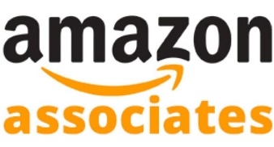
AMAZON ASSOCIATES
When you shop through one of our special Amazon links, ANP can earn up to 10% in referral fees on qualifying purchases: https://amzn.to/2KapLwo
Be sure to purchase your “Classics to Keep” Literature and Great Hearts Recommended Literature through one of our affiliate links.
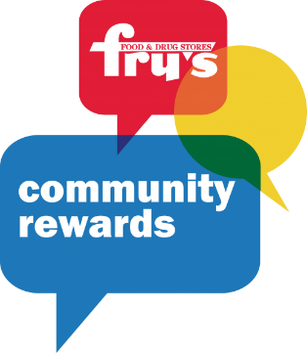
FRY’S FOOD STORES
You can support Archway North Phoenix just by shopping at Fry’s Food Stores. Simply enroll in Fry’s Community Rewards® Program and link your V.I.P. card to Archway North Phoenix Academy PSO.
Each August you must re-enroll your card into the Fry’s Community Rewards®! Program. It’s easy to enroll. Visit www.FrysCommunityRewards.com with your V.I.P card and select:
Archway North Phoenix Academy PSO or our Organization Number: FY265
Step by Step Instructions:
- Go to www.FrysCommunityRewards.com.
- Select ‘Enroll Now’.
- Enter your email address and password then select ‘Sign in’. (This will be the email and password tied to your Fry’s Account)
- Select ‘My Account’ from the drop-down menu.
- Select ‘Community Rewards’.
- Under ‘Find an Organization’ enter Archway North Phoenix Academy PSO (or Organization Number: FY265) and select ‘Search’.
- Select ‘Enroll’

**If you have registered correctly, you should now see Archway North Phoenix Academy PSO listed under ‘Community Rewards’.

Don’t have a Fry’s V.I.P card? No Problem. Create an Alt ID and then follow the steps listed above.
Make sure your receipt shows Archway North Phoenix Academy PSO the next time you shop.
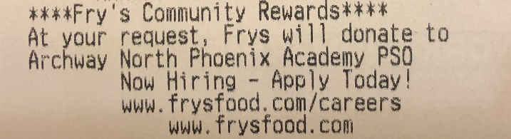

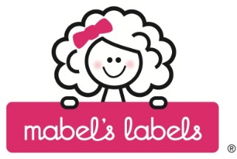
MABEL’S LABELS
Help us reduce our Lost & Found! Shop for labels to identify your belongings at http://campaigns.mabelslabels.com and search for Archway North Phoenix PSO. Mabel’s Labels will donate 20% of your purchase to ANP.

SHUTTERFLY
Shop at Shutterfly through this link http://anp.shutterflystorefront.com and 8% of your purchase will be donated to ANP.


HARKINS SUMMER MOVIE FUN
Purchase your Harkins Summer Movie Fun season tickets through ANP and up to 30% of sales will benefit our school. Kids can enjoy a movie a week for 10 weeks, for less than $1 per film. Watch for an order form to go home with your scholar in February.

BOX TOPS
Box Tops are going DIGITAL. The digital transition will take place over the next year, but some participating brands are beginning to change their packaging from physical Box Tops clips to a new Box Tops icon. Digital Box Tops will be earned by scanning your receipt within 14 days of purchase, on the Box Tops Mobile App.
https://www.boxtops4education.com/bonusapp

Box Tops will still honor all unexpired Box Tops clips, so keep clipping.
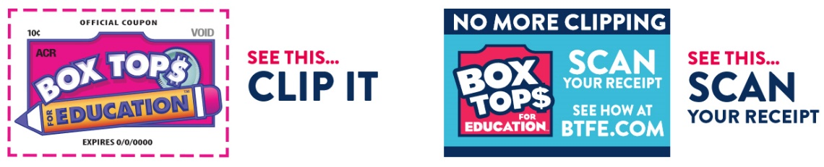
Additional Information:
Participating Products
Collection Sheets

COKE GIVES
With every purchase of Coca-Cola products, you can donate to ANP. Simply scan or enter the product codes at www.coke.com/give and our school will receive a donation between 5¢ and 38¢ (Code Values). Codes may be found on the plastic lids of bottles, cardboard packaging or under the plastic wrap.
If you don’t want to enter codes, send them to school with your Box Tops.
Participating Products:
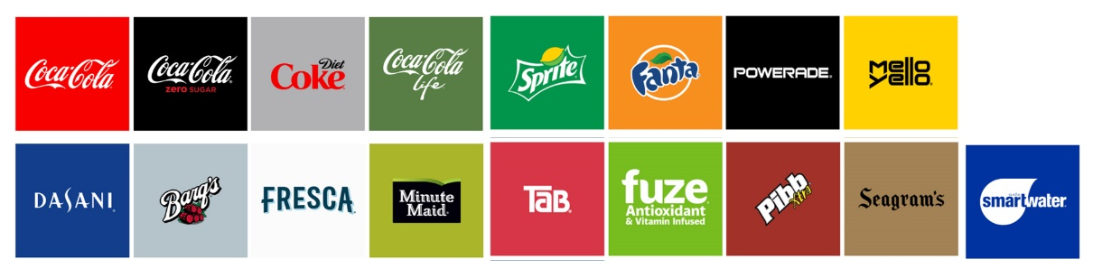

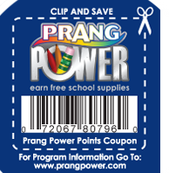
PRANG POWER
Clip the UPC codes found on Ticonderoga, Dixon, Prang, and DAS products and ANP can earn school & art supplies.
Clip and send them to school with your Box Tops.
Additional Information:
Program Information
Prang Power Parent Flyer

