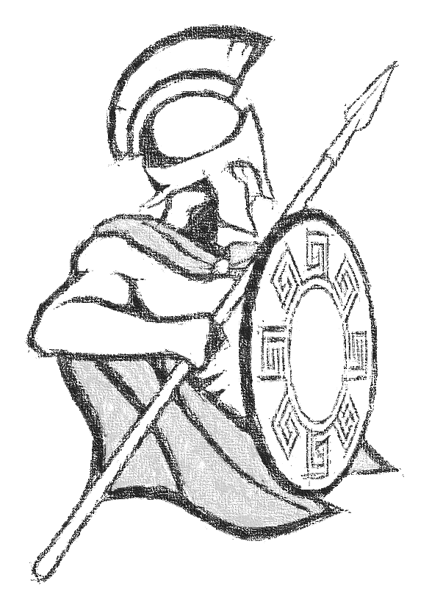

**Argonauts Sports Camp**

May 28th – May 31st

**To register for this camp, please follow these steps:**

1. **Visit** [**www.archwaynorthphoenix.configio.com**](http://www.archwaynorthphoenix.configio.com)
2. **Select “Extracurriculars”**
3. **Select “Argonauts Sports Camp”**

**Questions: email** [**srutt@archwaynorthphoenix.org**](mailto:srutt@archwaynorthphoenix.org)

**Focus will be on PLAY!**

At this camp, participants will have the opportunity to play a variety of traditional sports, international sports and invasion games. We will also have large blocks of time for students to have FREE PLAY time in which they can interact with others and play with a variety of equipment.

**Monday (5/27) –** Memorial Day (NO CAMP)

**Tuesday (5/28) –** Basketball and Soccer

**Wednesday (5/29) –** Volleyball and Kickball

**Thursday (5/30) –** International Sports (Ex: Rugby, Handball, etc.)

**Friday (5/31) –** Invasion Games (Ex: Capture the Flag, Dodgeball, etc.)

**Camp Highlights**

* Great outlet for physical activity during the hot summer
* Mostly indoors!
* Participants receive:
  + Camp Shirt
  + Certificate of Completion
  + Awards for Winning Teams
* Participants get lots of PLAY time!
* Opportunities to practice and learn team work skills.

**Details**

**Who:** Boys & Girls Entering 2nd – 6th Grade for the 2019-2020 School Year

**Where:**

Great Hearts North Phoenix Campus

14100 North 32nd Street | Phoenix, Arizona 85032 | Phone: (602) 996-4355

**When:** May 28th – May 31st

**Time:** 8:00 – 3:00

**Cost:** $150

**Camp Size:** Limit 60 campers

**What to Bring:** Campers should wear appropriate shoes, shorts and a t-shirt. All other equipment will be provided.

**Coaching:**

* Seth Rutt – ANP PE Teacher
* Dylan Waugh – ANP PE Teacher

**Lunch/ Snacks:** Please plan to pack your own snacks and lunch for each day of the week.

**Registration**

**Registration Opens:** Thursday, April 4th at 9:00am

**Registration Closes:** May 19th at 10:00pm

*Camp shirt only guaranteed if you register by May 19th*

**Argonauts Sports Camp**

May 28th – May 31st



**Focus will be on PLAY!**

At this camp, participants will have the opportunity to play a variety of traditional sports, international sports and invasion games. We will also have large blocks of time for students to have FREE PLAY time in which they can interact with others and play with a variety of equipment.

**Monday (5/27) –** Memorial Day (NO CAMP)

**Tuesday (5/28) –** Basketball and Soccer

**Wednesday (5/29) –** Volleyball and Kickball

**Thursday (5/30) –** International Sports (Ex: Rugby, Handball, etc.)

**Friday (5/31) –** Invasion Games (Ex: Capture the Flag, Dodgeball, etc.)

**Camp Highlights**

* Great outlet for physical activity during the hot summer
* Mostly indoors!
* Participants receive:
  + Camp Shirt
  + Certificate of Completion
  + Awards for Winning Teams
* Participants get lots of PLAY time!
* Opportunities to practice and learn team work skills.

**Details**

**Who:** Boys & Girls Entering 2nd – 6th Grade for the 2019-2020 School Year

**Where:**

Great Hearts North Phoenix Campus

14100 North 32nd Street | Phoenix, Arizona 85032 | Phone: (602) 996-4355

**When:** May 28th – May 31st

**Time:** 8:00 – 3:00

**Cost:** $150

**Camp Size:** Limit 60 campers

**What to Bring:** Campers should wear appropriate shoes, shorts and a t-shirt. All other equipment will be provided.

**Coaching:**

* Seth Rutt – ANP PE Teacher
* Dylan Waugh – ANP PE Teacher

**Lunch/ Snacks:** Please plan to pack your own snacks and lunch for each day of the week.

**To register for this camp, please follow these steps:**

1. **Visit** [**www.archwaynorthphoenix.configio.com**](http://www.archwaynorthphoenix.configio.com)
2. **Select “Extracurriculars”**
3. **Select “Argonauts Sports Camp”**

**Questions: email** [**srutt@archwaynorthphoenix.org**](mailto:srutt@archwaynorthphoenix.org)

**Registration**

**Registration Opens:** Thursday, April 4th at 9:00am

**Registration Closes:** May 19th at 10:00pm

*Camp shirt only guaranteed if you register by May 19th*